**Class 4 Lab questions**

#1. WAP to swap two integer numbers using third variable.

Code:

#include <stdio.h>

int main()

{

    printf("provide the numbers you want to swap respectively\n");

    int a426,b426,c426;

    scanf("%d%d",&a426,&b426);

    printf("The numbers before swapping are %d and %d\n",a426,b426);

    c426=a426;

    a426=b426;

    b426=c426;

    printf("after swap, the numbers are %d and %d\n",a426,b426);

    return 0;

}

Output:

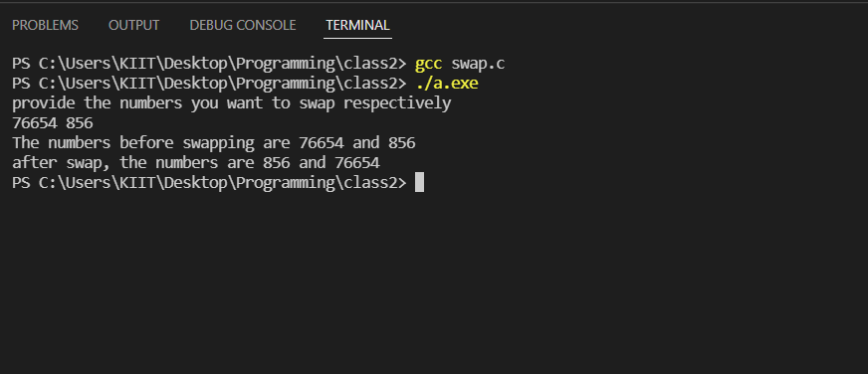



#2. WAP to convert given paisa into its equivalent rupee and paisa as per the following format. Example. 550 paisa = 5 Rupee and 50 paisa

Code:

#include <stdio.h>

int main()

{

    printf("Please state your paisa:\n");

    int total426,qou426,rem426;

    scanf("%d",&total426);

    qou426=total426/100;

    rem426= total426%100;

    printf("%d paisa is %d rupees and %d paisa",total426,qou426,rem426);

    return 0;

}

Output:

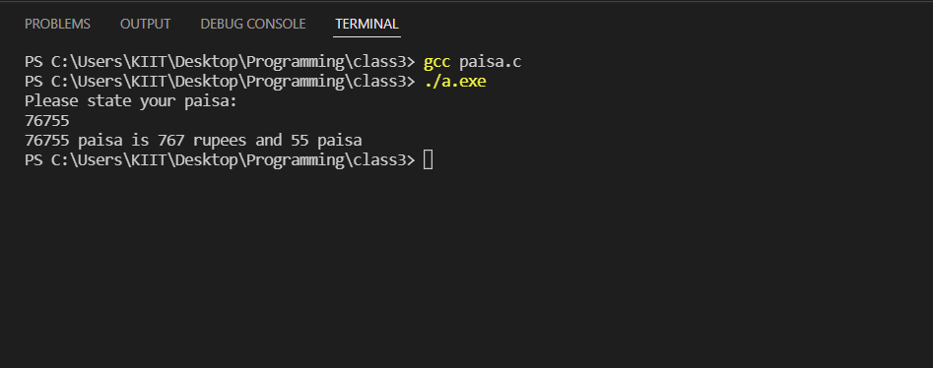

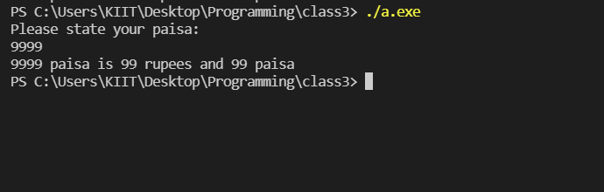

#3. WAP to convert given second into its equivalent hour, minute and second as per the following format. Example. 7560 second = 2 Hour, 27 Minute and 40 Second

Code:

#include <stdio.h>

int main()

{

  long given426, hour426, sec426, min426, last426;

  printf("Provide the total seconds\n");

  scanf("%ld",&given426);

  hour426=given426/3600;

  sec426= given426%3600;

  min426= sec426/60;

  last426= sec426%60;

  printf("%ld seconds is %ld hours %ld minutes and %ld seconds",given426,hour426,min426,last426);

  return 0;

}

Output:

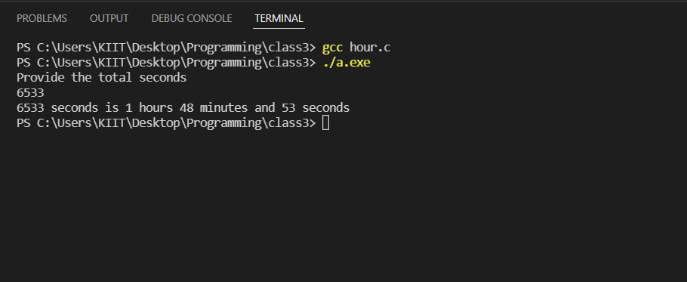

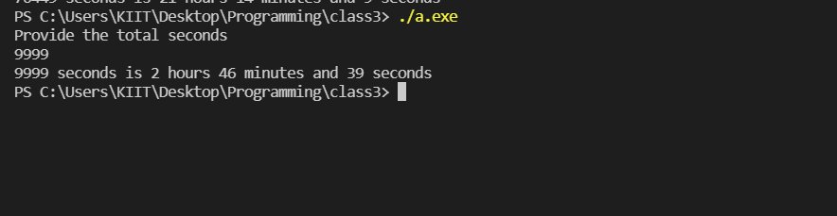

#4. WAP to subtract a number from another number and display the result.

Code:

#include <stdio.h>

int main()

{

    printf("provide the numbers you want to subtract respectively\n");

    float a426,b426,c426;

    scanf("%f%f",&a426,&b426);

    c426=a426-b426;

    printf("the result %f-%f=%f",a426,b426,c426);

    return 0;

}

Output:

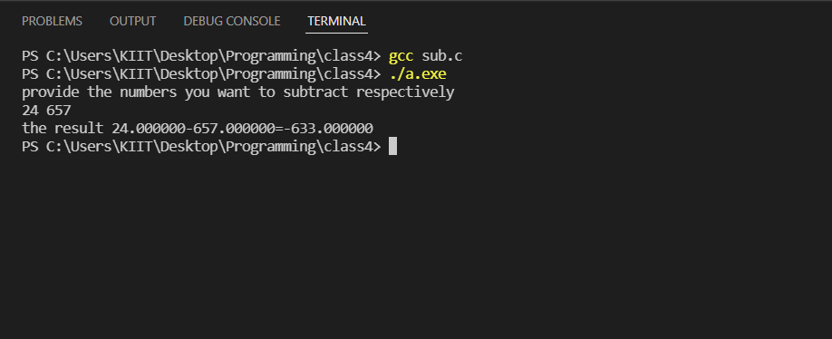

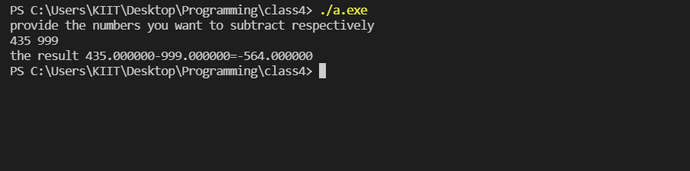

#5. WAP to calculate perimeter of a circle.

Code:

#include <stdio.h>

int main()

{

    printf("give the radius of your circle:\n");

    float rad426,per426;

    scanf("%f",&rad426);

    per426 = 3.14*rad426*2;

    printf("The perimeter of your circle is %f",per426);

    return 0;

}

Output:

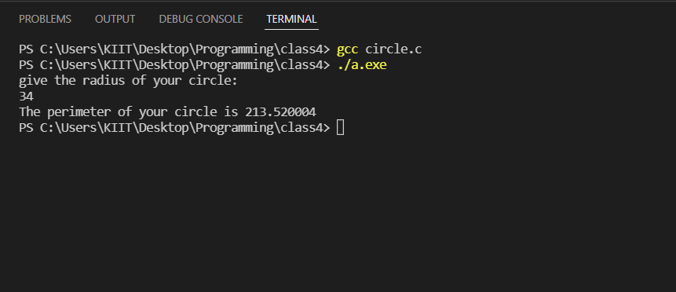

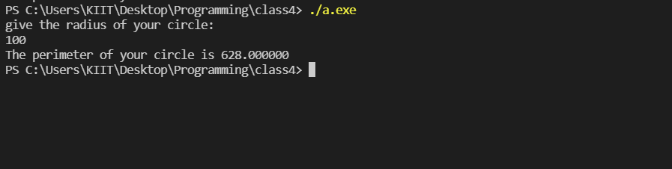

#6. WAP to find the largest between two numbers.

Code:

#include <stdio.h>

int main()

{

    printf("Provide the numbers you want to compare:\n");

    float a426,b426;

    scanf("%f%f",&a426,&b426);

    if (a426<b426) {

        printf("The larger number is %f",b426);

    }

    else {

        printf("The larger number is %f",a426);

    }

    return 0;

}

Output:

